**JQuery Termwork**

1. Write a jquery code to hide and show an element on button click.

<html>

<head>

<title>JQuery Term Word 1</title>

<script src = "https://ajax.googleapis.com/ajax/libs/jquery/3.4.1/jquery.min.js">

</script>

<script>

$(document).ready(function(){

$("button").click(function(){

$("#para").hide();

})

});

</script>

</head>

<body>

<p id = "para">Click the button to hide me!.</p>

<Button type = "Button">Click Now</Button>

</body>

</html>

**OUTPUT**

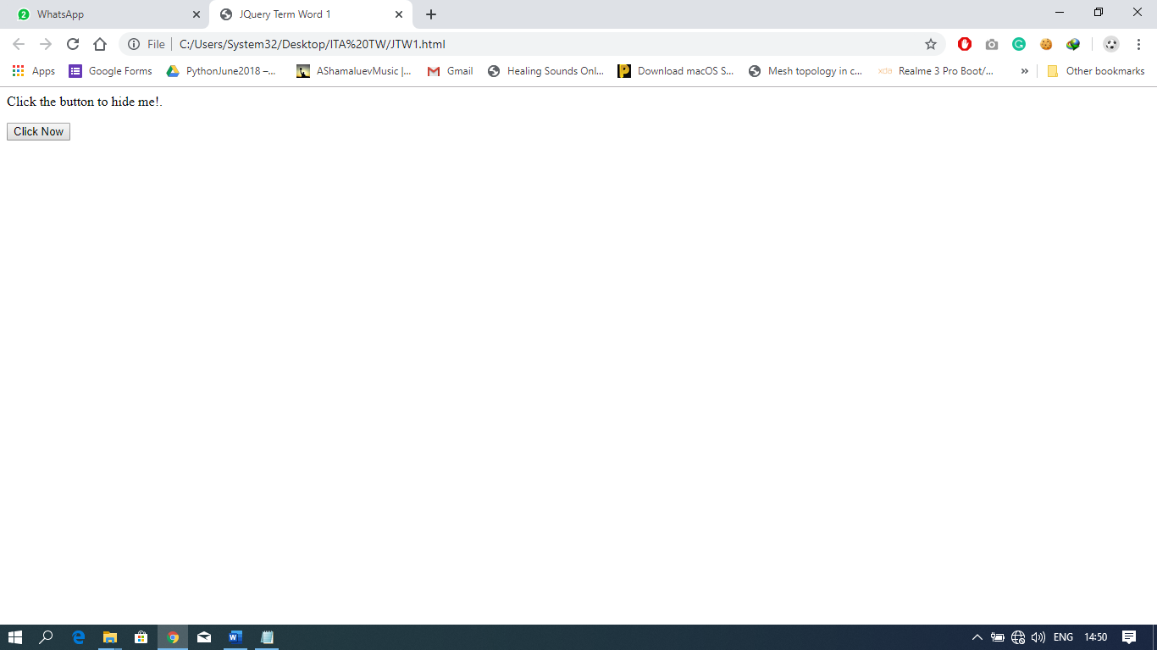

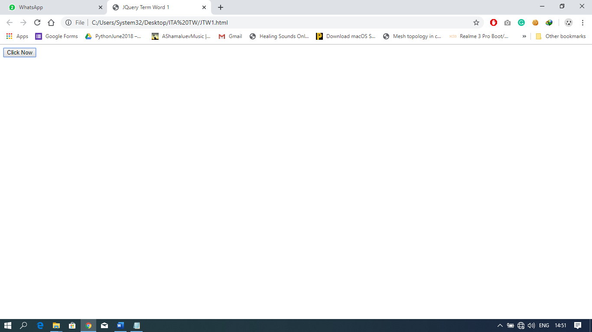

1. Write a jquery code to change the size, background color of a paragraph when user clicks on it.

<html>

<head>

<title> JQuery TermWork2 </title>

<script src="https://ajax.googleapis.com/ajax/libs/jquery/3.4.1/jquery.min.js">

</script>

<script>

$(document).ready(function(){

$("p").click(function(){

$("p").css({"background-color": "yellow", "font-size": "200%"});

});

});

</script>

</head>

<body>

<p>Click me to see the magic.</p>

</body>

</html>

**OUTPUT**

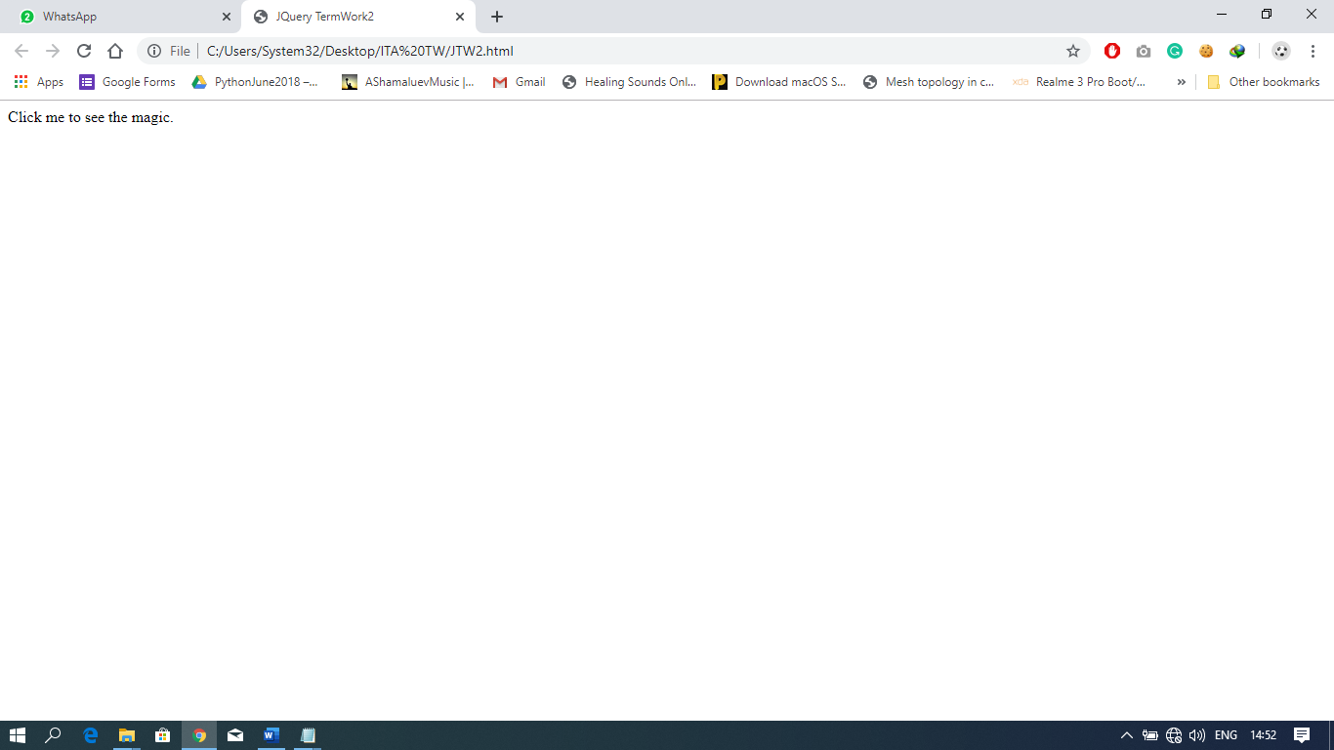

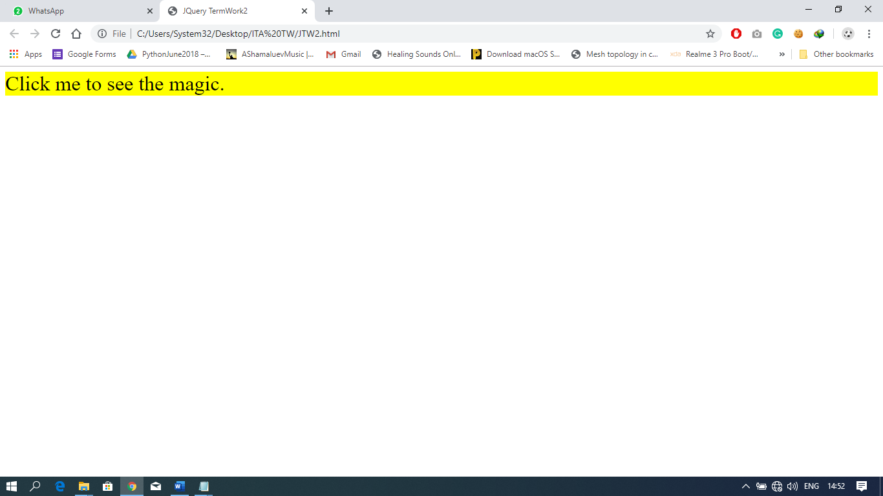

1. Write a jquery code to display text which user enters into the text box dynamically.

<html>

<head>

<title>JQuery Term Work 3</title>

<script src="https://ajax.googleapis.com/ajax/libs/jquery/3.4.1/jquery.min.js">

</script>

<script>

$(document).ready(function(){

$("input").keyup(function(event){

newText = event.target.value;

$("p").text(newText);

});

});

</script>

<body>

<p> Type in the box below and see it here.</p>

<br>

<form>

<input type = "text" id = "inp">

</form>

</body>

</html>

**OUTPUT**

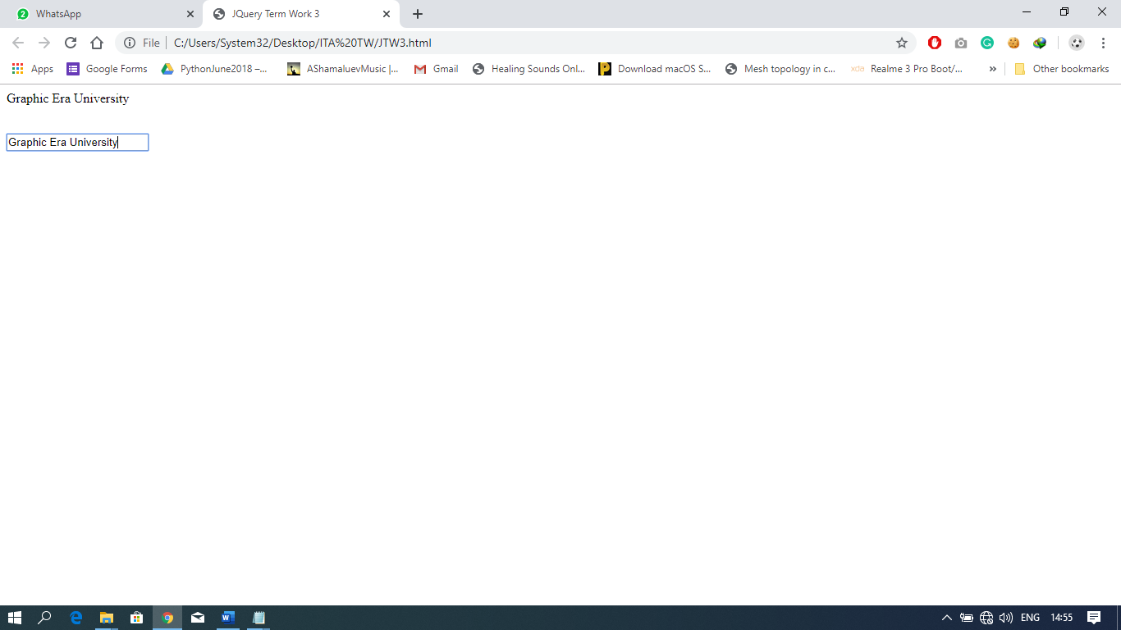

1. Write a jquery code to demonstrate fadeIn() with different parameters.

**Part 1**

<html>

<head>

<script src="https://ajax.googleapis.com/ajax/libs/jquery/3.4.1/jquery.min.js"></script>

<script>

$(document).ready(function(){

$(".btn1").click(function(){

$("p").fadeOut(1000, function(){

alert("fadeOut() method is finished!");

});

});

$(".btn2").click(function(){

$("p").fadeIn(1000, function(){

alert("fadeIn() method is finished!");

});

});

});

</script>

</head>

<body>

<p>This is a paragraph.</p>

<button class="btn1">Fade out</button>

<button class="btn2">Fade in</button>

</body>

</html>

**Part 2**

<html>

<head>

<script src="https://ajax.googleapis.com/ajax/libs/jquery/3.4.1/jquery.min.js"></script>

<script>

$(document).ready(function(){

$(".btn1").click(function(){

$("p").fadeOut(1000);

});

$(".btn2").click(function(){

$("p").fadeIn(1000);

});

});

</script>

</head>

<body>

<button class="btn1">Fade out</button>

<button class="btn2">Fade in</button>

<p>This is a paragraph.</p>

</body>

</html>

**OUTPUT**

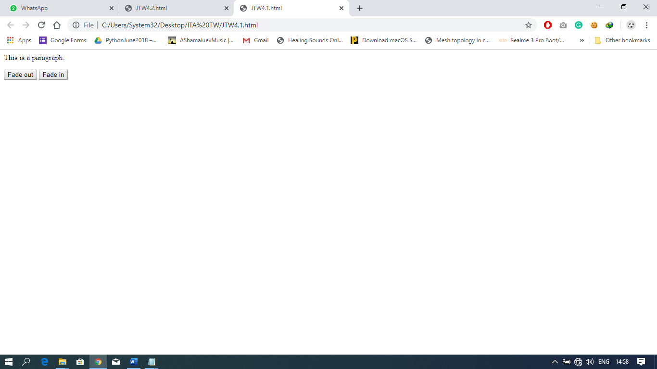

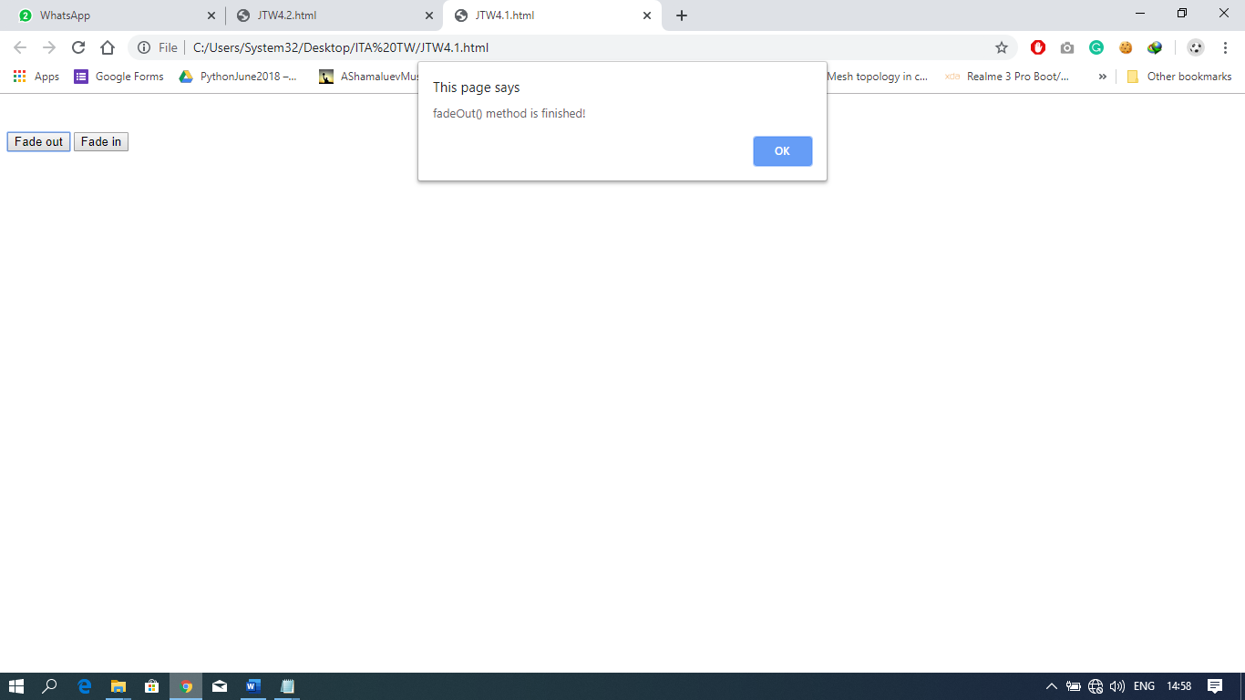

1. Write a jquery code to display the content of button in a textbox when user clicks on the button.

<html>

<head>

<title>JQuery Term Work 5 </title>

<script src = "https://ajax.googleapis.com/ajax/libs/jquery/3.4.1/jquery.min.js">

</script>

<script>

$(document).ready(function(){

$("button").click(function(){

var a = document.getElementById("inp").innerHTML

$('p').text(a); })

});

</script>

</head>

<body>

<p> Click the button to show it's name here. </p>

<br>

<button id = "inp"> Click Me!</button>

</body>

</html>

**OUTPUT**

